Types of Adjuncts
# Source: AI Source: Provided by: [Data Path: Persons Table -> ID Column: 1, Name_En Column: Motasem Essam] -> From: [Chatgpt (GPT-4-turbo)] on [8/5/2025]
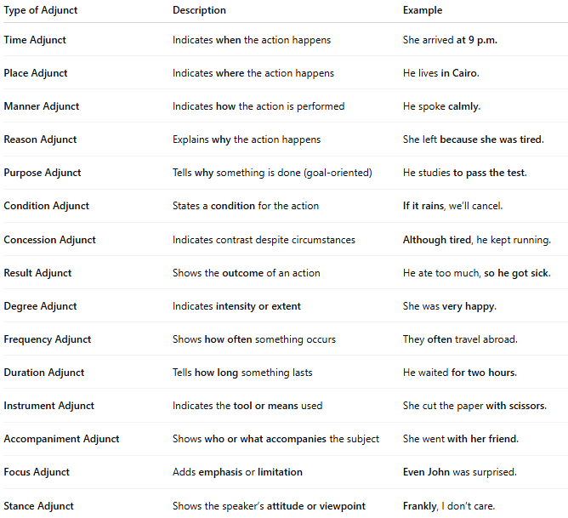

Type of Adjunct | Description | Example
Time Adjunct | Indicates when the action happens | She arrived at 9 p.m.
Place Adjunct | Indicates where the action happens | He lives in Cairo.
Manner Adjunct | Indicates how the action is performed | He spoke calmly.
Reason Adjunct | Explains why the action happens | She left because she was tired.
Purpose Adjunct | Tells why something is done (goal-oriented) | He studies to pass the test.
Condition Adjunct | States a condition for the action | If it rains, we’ll cancel.
Concession Adjunct | Indicates contrast despite circumstances | Although tired, he kept running.
Result Adjunct | Shows the outcome of an action | He ate too much, so he got sick.
Degree Adjunct | Indicates intensity or extent | She was very happy.
Frequency Adjunct | Shows how often something occurs | They often travel abroad.
Duration Adjunct | Tells how long something lasts | He waited for two hours.
Instrument Adjunct | Indicates the tool or means used | She cut the paper with scissors.
Accompaniment Adjunct | Shows who or what accompanies the subject | She went with her friend.
Focus Adjunct | Adds emphasis or limitation | Even John was surprised.
Stance Adjunct | Shows the speaker’s attitude or viewpoint | Frankly, I don’t care.

